**How to embed Power BI in Dynamics 365 for Sales and Marketing**

The Power BI for Office 365 cloud service works with model-driven apps in Dynamics 365, such as Dynamics 365 Sales and Customer Service, to provide a self-service analytics solution. Power BI automatically refreshes the data displayed. With Power BI Desktop or Office Excel Power Query for authoring reports and Power BI for sharing dashboards and refreshing data from model-driven apps in Dynamics 365, sales, marketing, and service personnel in your organization have a powerful new way to work with data.

**Step 1: Use Power BI Desktop to connect directly to your Dynamics 365 environment**

You can connect to model-driven apps in Dynamics 365 with Power BI Desktop to create custom reports and dashboards for use with the Power BI service.

### Connect to Dynamics 365 (online) apps

1. Start Power BI Desktop.
2. From the Home tab, click **Get Data**, and then click **More**.
3. In the Get Data list, select **Dynamics 365 Online**.
4. Enter the Dynamics 365 (online) apps OData endpoint URL. It should look similar to this URL, where OrganizationName is the name of your Dynamics 365 (online) apps organization, and **v8.1** is the version. Click **OK**.

Example : <https://teamsdevtrainer.crm.dynamics.com/api/data/v8.1>

1. In the Access an OData feed dialog click **Organizational account**, and then click **Connect**.
2. The organization database entity tables appear in the Power BI Desktop Navigator window. You can select both default and custom entities. For more information about creating reports with Power BI Desktop.
3. Make a Power BI report, for our lab I used Sales Manager.pbix files available in Lab Files
4. Save and Publish the Report

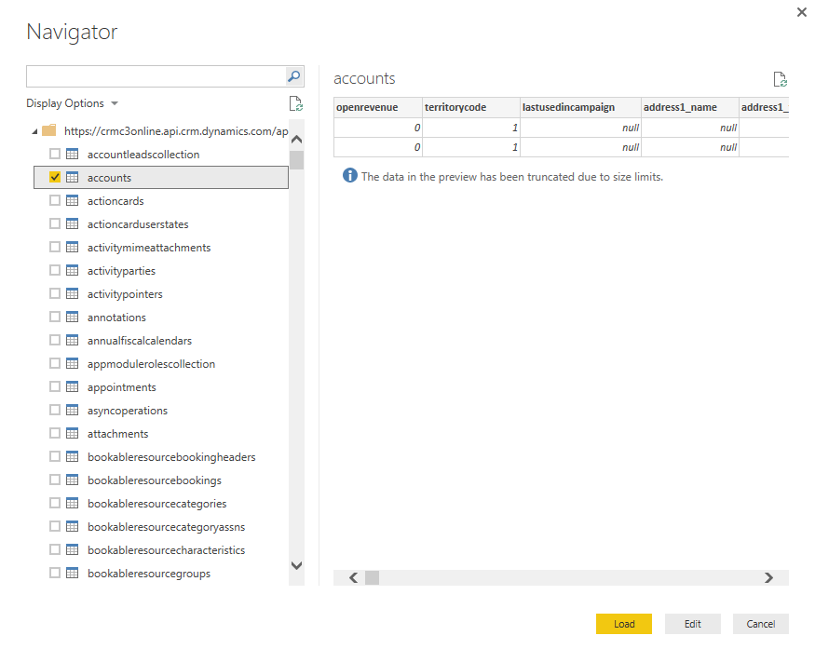

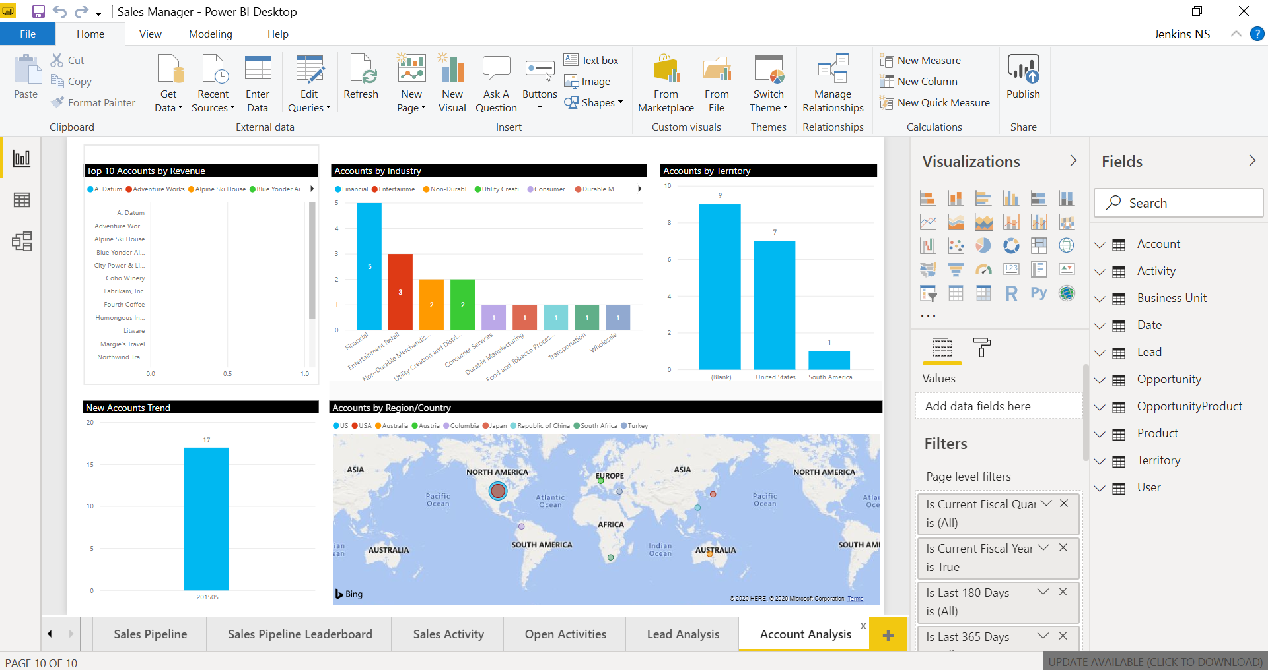

## Step 2: Create a dashboard by pinning visuals and images from a report

1. Open the Power BI service in your browser (app.powerbi.com)
2. Go to your workspace 🡪 Reports
3. Select our Sales Manager Report

### **Open the report and pin tiles to your dashboard**

1. In the same workspace, select the **Reports** tab, and then select **Sales Manager** to open the report.
2. Edit Report
3. Go to your report page and pin the sections

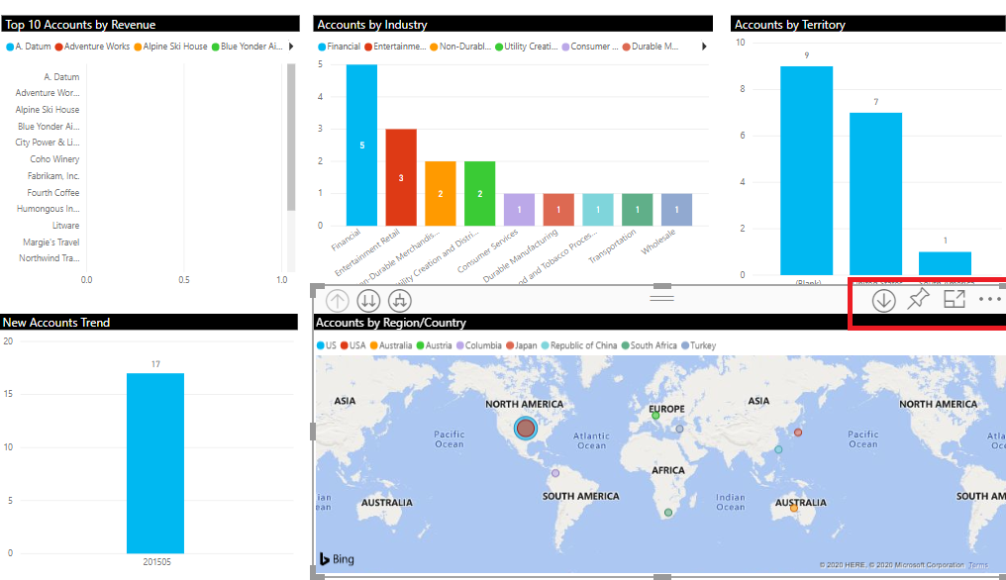

1. Create new dashboard

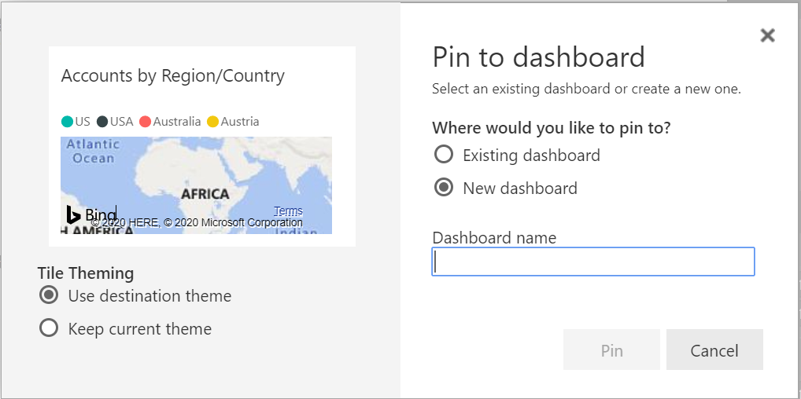

1. Same way pin all the required report sections and update the dashboard

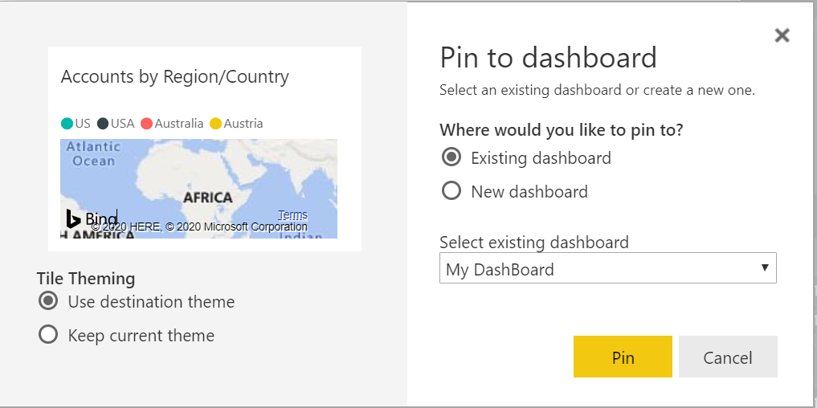

1. Finally, we get the dashboard like below, I named “My dashboard”

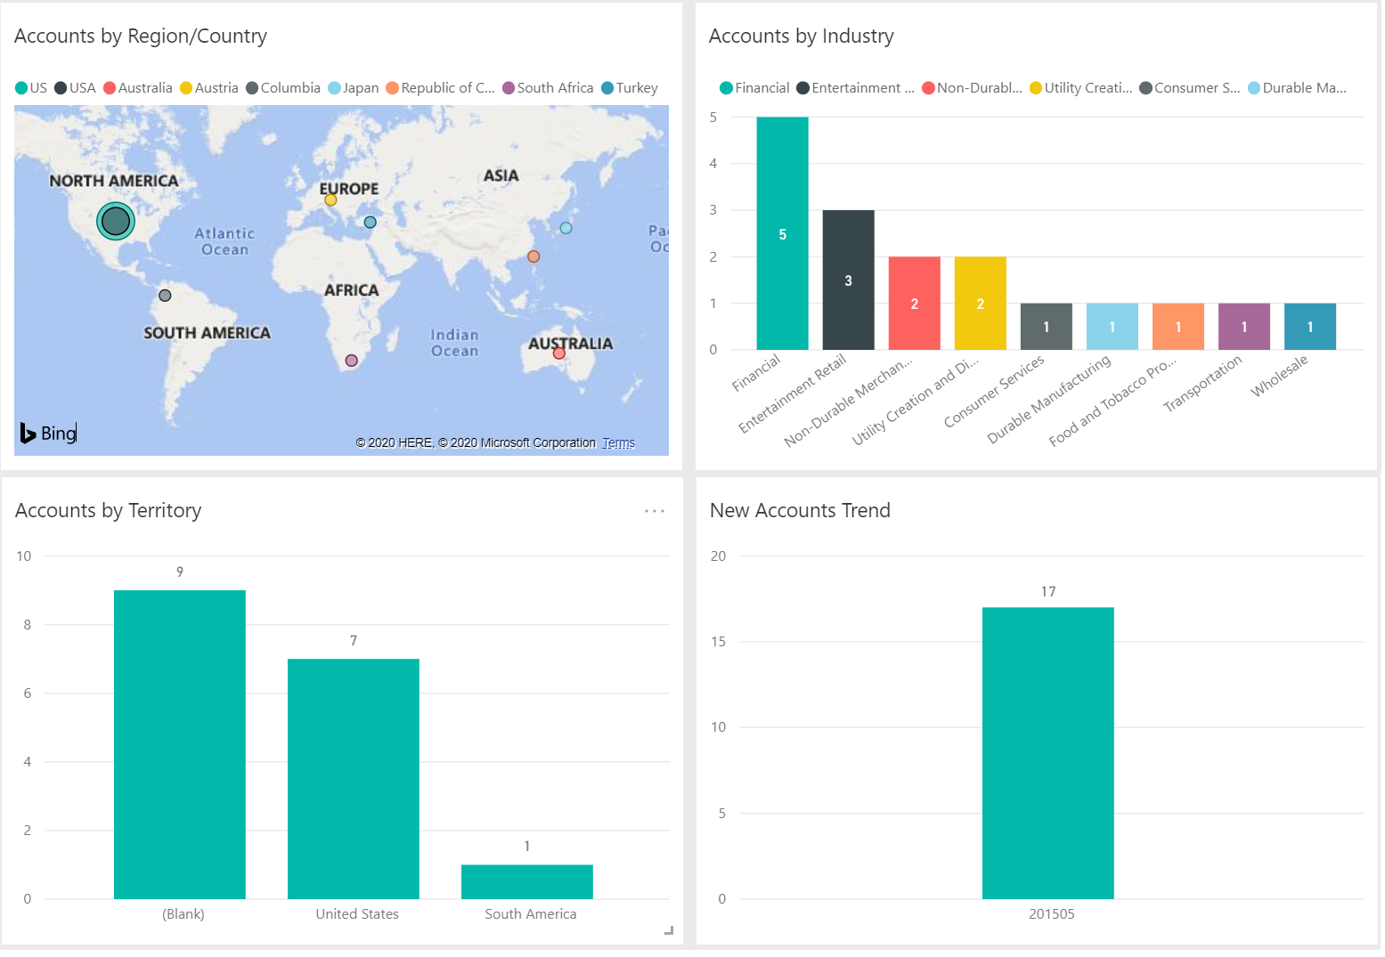

### **Step 3: Enable Power BI visualizations in the organization**

1. Sign-in to model-driven apps in Dynamics 365 as a user with the system administrator security role.
2. Settings 🡪 Advanced Settings

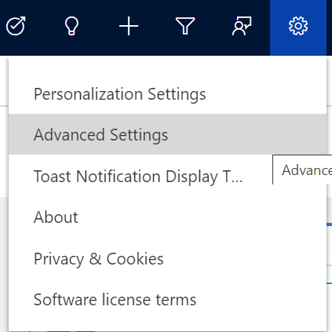

1. Click Settings 🡪 **Administration**

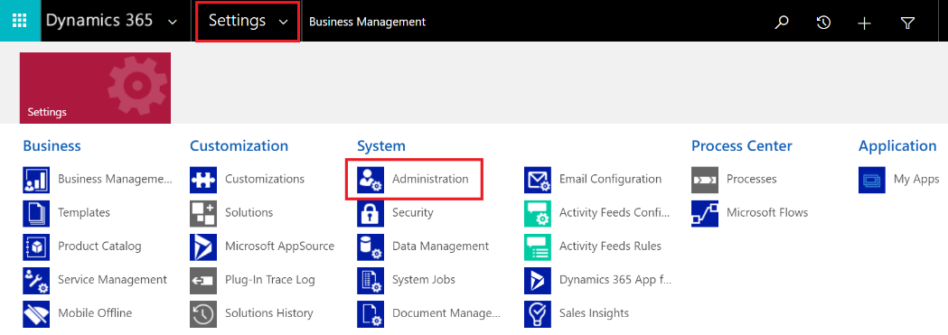

1. Go to **System Settings**.

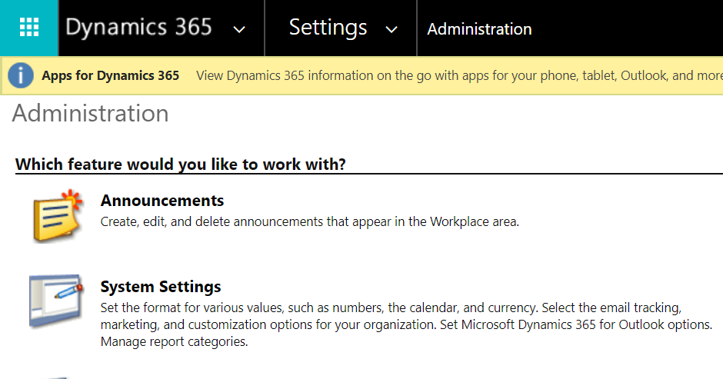

1. On the **Reporting** tab in the **Allow Power BI visualization embedding** option, select **Yes** to enable or **No** to disable.

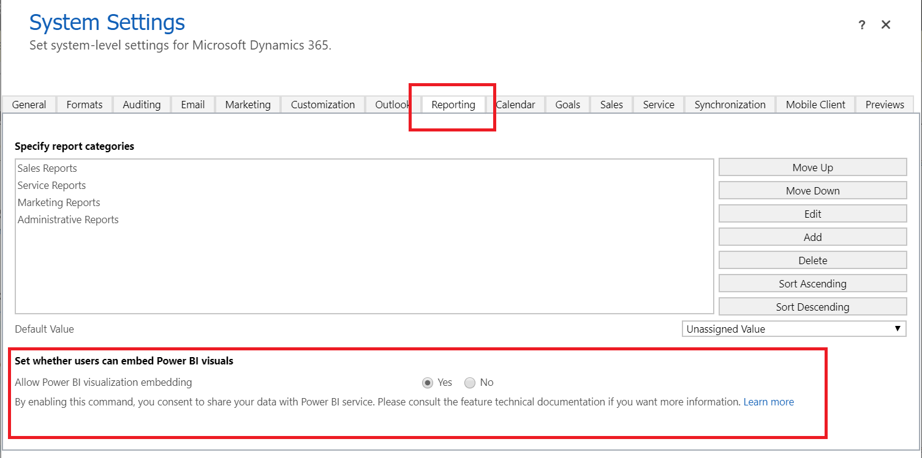

1. Click **OK**.

**Step 4: Add or edit Power BI visualizations on your dashboard**

Create rich, interactive reports and real-time visualizations with Power BI dashboards and tiles that you add to your personal dashboards, follow step 1 and create rich dashboards.

1. Open your app and go to **Dashboards**.
2. Select **New** and then select **Power BI Dashboard**.

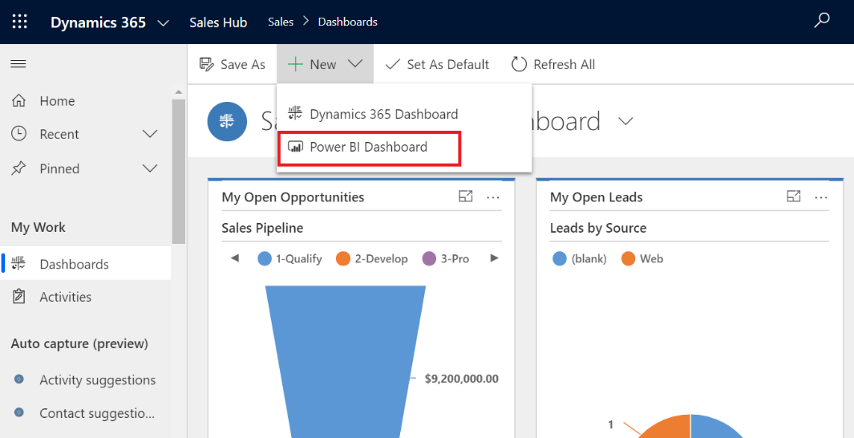

1. In the **Power BI Dashboard Properties** dialog select the workspace and then select the Power BI dashboard that you want to embed in your dashboard. Select **Enable for mobile** if you want to make the dashboard available for Dynamics 365 for tablets and Dynamics 365 for phones.

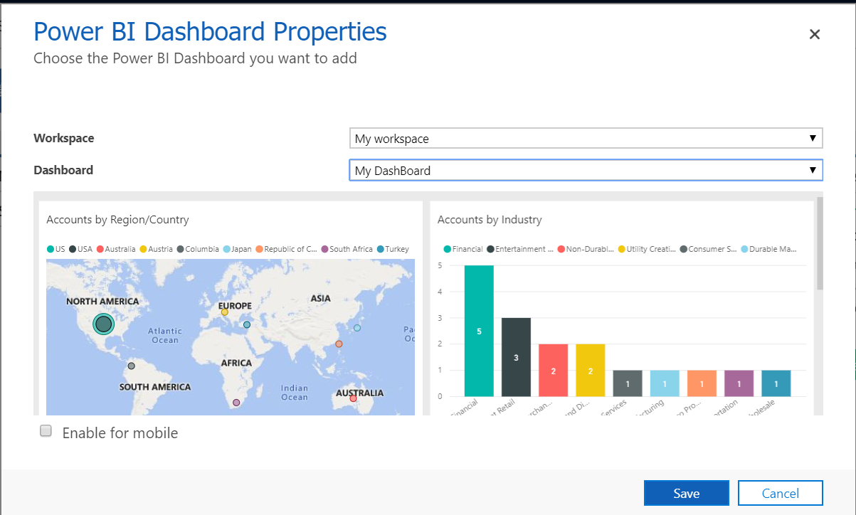

1. Select **Save** to save your dashboard.
2. My Dashboard loaded in Dynamics 365 Sales Hub

